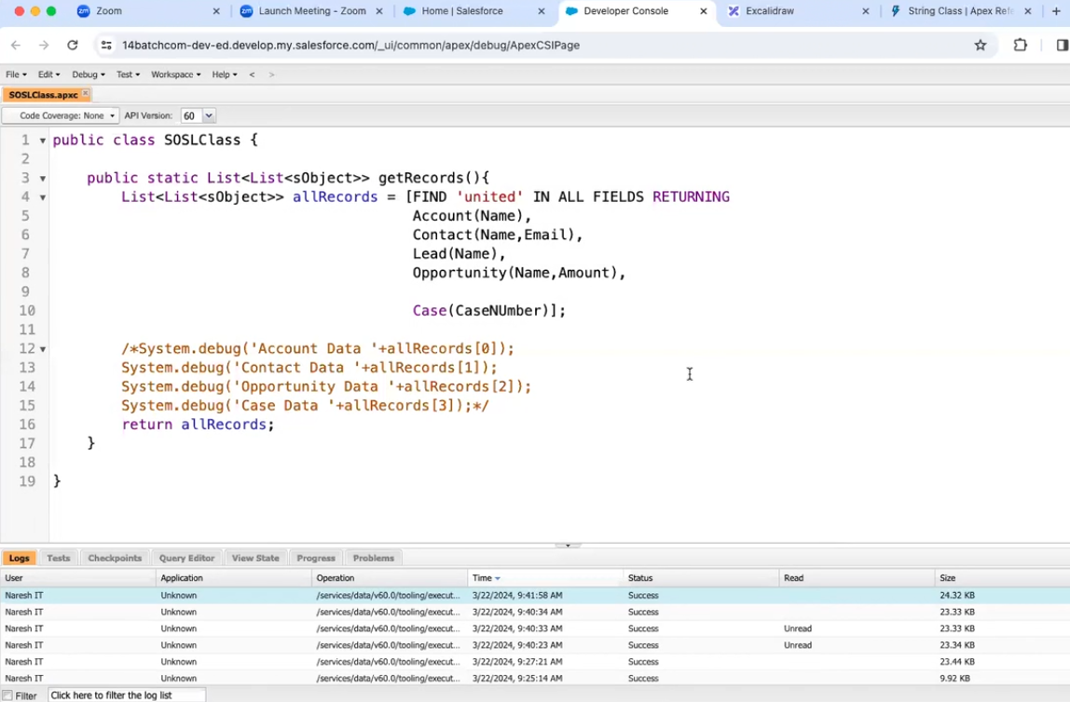

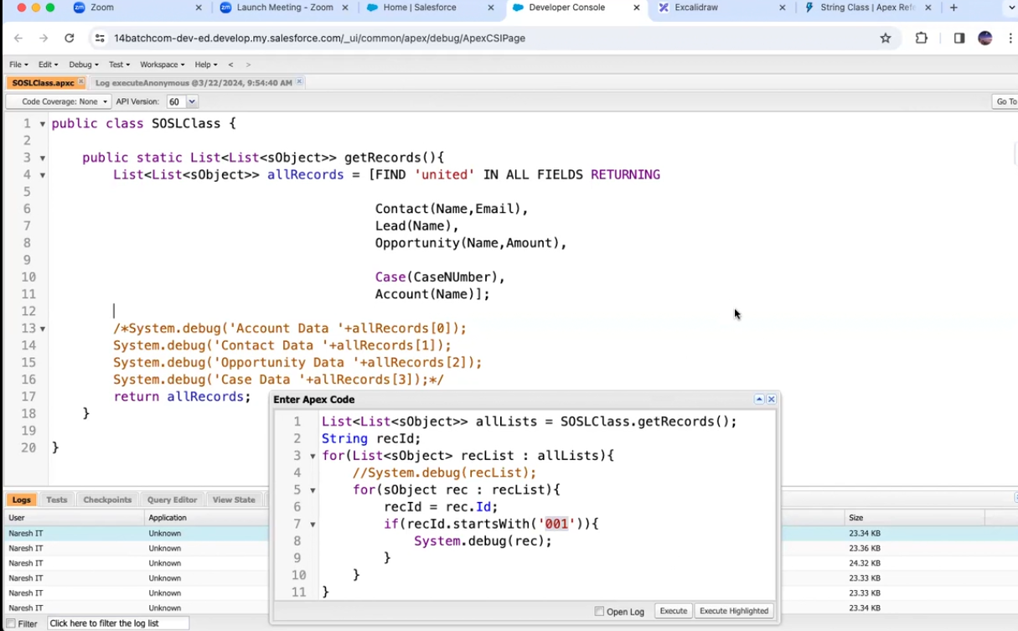

Here we are using record id, not index positions

If any on change position also no problem

Now custom objects

Custom objects are not supporting here

For opportunity

We have another approach

If we know the record ID what the object API name, we are getting



